Think About What You Think
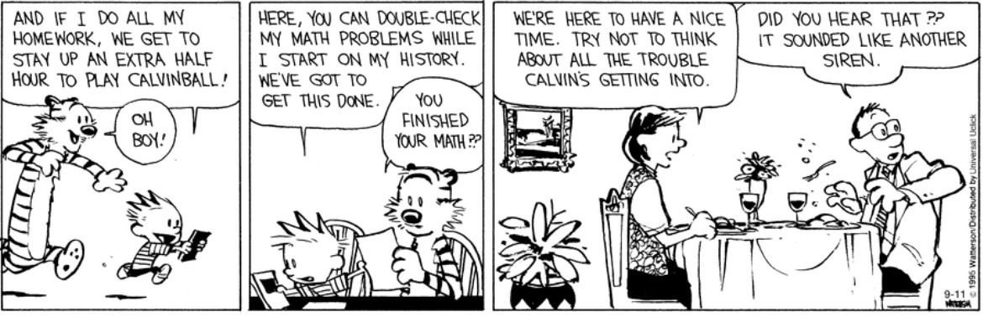
“Unlike other forms of psychological disorders, the core issue in trauma is reality.” ~ Bessel A. van der Kolk

They're All Rhetorical...
Do you associate fear with PTSD? Do you believe that PTSD is more harmful for women? What about men with PTSD? How do their symptoms look? What kind of coping skills do men with PTSD use? Is it different than women’s coping skills?
Think about these questions as you watch "The Work."

The Prompt...
You are part of a pilot program that highlights the benefits of doing group work among peers. Folsom Prison is the ideal location due to the fact that most if not all the population have suffered some form of trauma or may actually be diagnosed with PTSD.

Assignment Instructions
- Watch the documentary "The Work - Group Therapy with Folsom Prison Inmates" on Kanopy.com
- The Kanopy site sign up directions are listed below.
- Pick a person from this documentary and discuss how trauma/PTSD may have contributed to where they are and how their group work is helping them to process their trauma.
- Write two fully thought out and complete paragraphs.
- The 20 point assignment is due on Sunday, November 14, 2021 at 11:59 pm.

Sign Up for Your Free Kanopy Account to Watch "The Work."

Directions
- Go to Kanopy
- Select “Find your university” and type in Merritt College (or if you already have an account, log in and go to The Work-Documentary.)
- Select “Login to Merritt”
- Select “Merritt Student”
- Sign in using your peralta.edu ID and password (the same one you use when you log on to register for classes)
- Create your account by filling out the blank fields or use Google/Facebook
- Type in the search bar at the top of the screen The Work - Group Therapy with Folsom Prison Inmates

It will look like this:
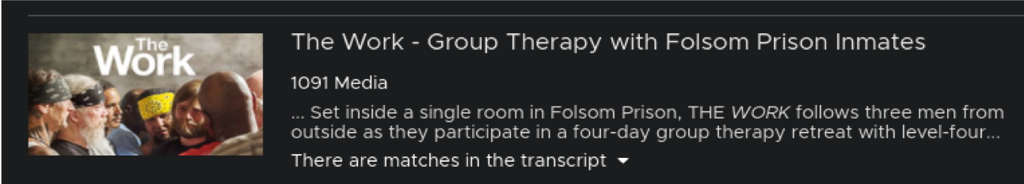

Think About What You Think
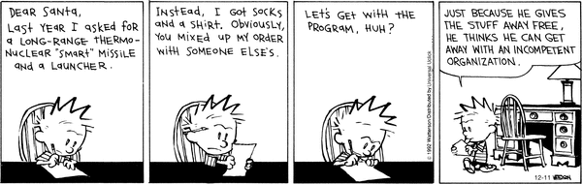
"Organizational structures of today demand too much from a few, and not much at all from everyone else." ~ Gary Hamel

Food for Thought...
The titles of those in an organization's hierarchical structure is not the lens through which we should view our peers.
Think about this statement as you complete the rest of the assignment. Make sure you follow "The Assignment Instructions."

The Prompt
The goal of functional organizational structure is to put all the required human and informational resources in position to maximize performance and accomplish an objective. Nevertheless, hierarchical organizational structures often operate with high levels of formalization, which, too often, makes communication with internal departments and other organizations quite difficult. These challenges lead to siloed work processes, which can make decision-making processes slow and inflexible also. Because of the pervasiveness of hierarchical bureaucracy and red tape, there is rarely any accountability, which leads to the waste of resources and poor coordination within the departments and with outside organizations. As a result, a lack of innovation, restricted views of organizational goals, high expectations, and low pay can affect employees' motivation. Even though functional units often perform with a high level of efficiency, their level of cooperation with each other is sometimes compromised. Too often, certain groups struggle work cohesively with one another; others are territorial and uncooperative. This is usually caused by competition for limited resources. which can lead to infighting and reduced commitment due to competing interests. Wasted time and resources, ultimately can undermine commitment to the organization's mission and goals.

The Instructions
- Watch the "What is a non profit organization?" video here and the "Holacracy by Brian Robertson - BOOK SUMMARY" video here.
- Referencing the videos, your textbook (pgs. 361-369), and other resources discuss the benefits of a healthy non-profit organizational structure.
- Are organizational structures in the non-profit sector a hinderance to the growth, success, and sustainability of a non-profit organization? How? Why?

Your Assignment Response
- For this assignment, your response should be a minimum of two complete paragraphs.
- The assignment due date is Sunday, November 14, 2021 at 11:59 pm

Think About What You Think

“Transparency may be the most disruptive and far-reaching innovation to come out of social media.” ~ Paul Gillin

Food for Thought...
When utilized effectively, an organization's social media content asks and answers the right questions. It doesn’t love itself. It informs and educates by being trustworthy and presenting a balanced point of view.
Think about this statement as you complete the rest of the assignment. Make sure you follow "The Discussion Instructions."

The Prompt
In the 21st century, many nonprofit organizations use social media on a daily basis. About 70% of people engage with social media. Many of these are people who can be compelled to take further action regarding a specific cause. Social media has become a great resource to raise awareness about a cause, an event, or fundraising initiatives. Thus, we can safely say social media is a valuable platform for nonprofit organizations. Although engagement is an important metric, sentiment analysis is much more helpful. A sentiment analysis allows an organization to conduct an evidence based evaluation of how it is perceived, which is ultimately an indicator of how your clients and colleagues feel about you. What we are really talking about is your and your organization's reputation, so try to be prompt when responding to inquiries and consistent with your messaging about your organization's cause. This way, the focus is the organization's mission. So, how does a non-profit organization optimize its social media presence?When you are measuring the impact of your organization's social media presence, don’t get caught up in the number of followers per se. A large number of followers may help an organization expand, but the number of followers should not be the primary objective.

The Instructions
- Watch the "How to Create a Social Media Strategy for Your Nonprofit" video here.
- Referencing the video, your textbook (pgs. 369-371), and other resources, discuss the importance of social media as a marketing strategy for program awareness and fundraising in the non-profit sector.
- What is required from a non-profit organization to establish an effective social media impact?
- Your submission word count is 300 - 500 words.

Note:

  - You must submit a post BEFORE you can see your classmates posts.
  - Your replies to your classmates should consist of a complete thought that contributes to the dialogue and furthers the discussion. "I agree" or "I like what you said" does not meet this criteria.
  - There are no right or wrong responses, so share your knowledge, insights and thoughts freely, but please be respectful to one another as you explore and discuss your ideas.
  - See the discussion rubric (in rubric link on the navigation bar) for grading criteria.
  - Discussion is due on Sunday, November 14, 2021 at 11:59pm

